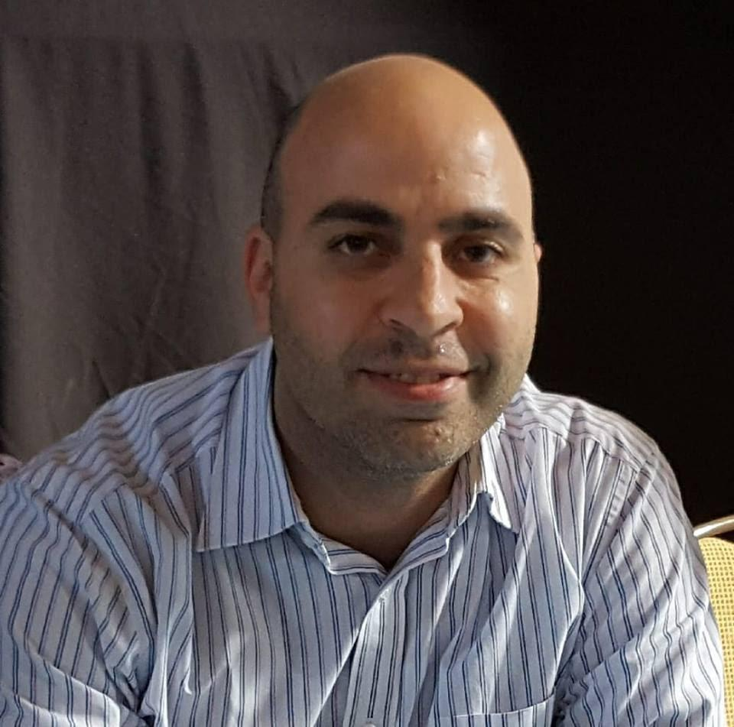

**Dr Mohamed Abdel-Wahab,** *BSc MSc EngD (Loughborough) PgCert PGCAP FHEA*

Mohamed is a Senior Lecturer in Construction Engineering Management and fellow of the UK Higher Education Academy. He is passionate about applied research projects for supporting the digital transformation of the construction industry for enhancing both training and practice. His portfolio of applied research is in excess of £0.5-million which was funded by various organisations, such as: CITB, Morrison Construction (Galliford Try), Thomson Bethune, Scottish Government, European Regional Development Fund, UK Commission for Employment and Skills, Skills Development Scotland, Energy Skills Partnership, and Scottish Funding Council. His research won a number of industry awards, such as: 2-CIOB awards, namely: Premier award in the Digital Innovation category; and Highly Commended award in the Innovation in Education & Training category. Recently, his collaborative project on VR for H&S training was a finalist in the Water Industry Awards 2018 and featured in industry press. He was recently a panellist at #ScotlandBuild 2019 discussing the state of digital transformation in the construction industry.

### 

### Julie Adair

Director of Digital Collaboration

Glasgow Caledonian University

* +44 (0)141 331 3463
* julie.adair@gcu.ac.uk

Julie Adair has worked in interactive content and the media over many years, holding senior roles at global media and entertainment companies. She was part of the birth of BBC Online and contributed to many of the new services launched as the web grew within the BBC, particularly blogging, community services and events, games and education. At The Walt Disney Company as Director of Online EMEA, Julie was responsible for growing teams and content in twenty-three countries across Europe, as well as developing output for mobile and tablet platforms.

Julie joined Glasgow Caledonian University in November 2014 to develop and launch an innovative social impact digital platform, now named Common Good First. This received EU Erasmus+ funding in October 2016 and will be delivered through a consortium of European and South African partners.

She has advised the Scottish Government on Digital policy for children and young people and also sits on the Government’s Industry Leadership Group for Digital Media. Julie is a Visiting Professor of Interactivity, Content and Communities at the University of Abertay, Dundee.